4.

RAASC SUPPLY PLATOONS HONOUR ROLL

Bruce Gordon ARBON |  | Gordon MEARS
Bob BARKER |  | Ian MIDDLETON
Dean Relby BELLCHAMBERS |  | Allen Brian MOSS
Michael John BRYANT |  | Peter Gary NELSON
Rex BYRNES |  | Don NOY
Peter George CLAY |  | Les PATTERSON
Robert COOPER |  | John PENFOLD
Robert Charles CROUCH |  | Francis PONTING
Paul CURRAN |  | William T PRIESTLAND
Robert EVANS |  | Rodney QUINN
Henry FABISIAK |  | Gregory RICHEY
Perrin James GOODWIN |  | William STANDFAST
Michael HARTAS |  | Henry THORPE
Anthony John HAZEL |  | Peter John TUCKETT
Ronald Francis HERRING |  | Henricus VAN DARTEL
John JORDAN |  | Mannie VAN RIJSEWIJK
Donald Alfred JOSE |  | Ian George WANSTALL
Trevor KING |  | James WATTON
Keith LUFF |  | Alan Edwin WINSHIP
Brian McKEOWN |  | Paul Gerald YORK

BOWRAVILLE CENOTAPH

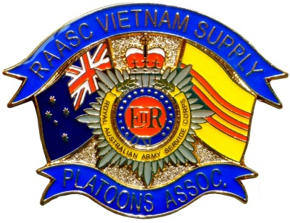

RAASC VIETNAM SUPPLY PLATOONS ASSOCIATION (VSPA)

COMMEMORATIVE SERVICE

Friday 22 March 2019 at 10.45 hrs

ORDER OF SERVICE

2.
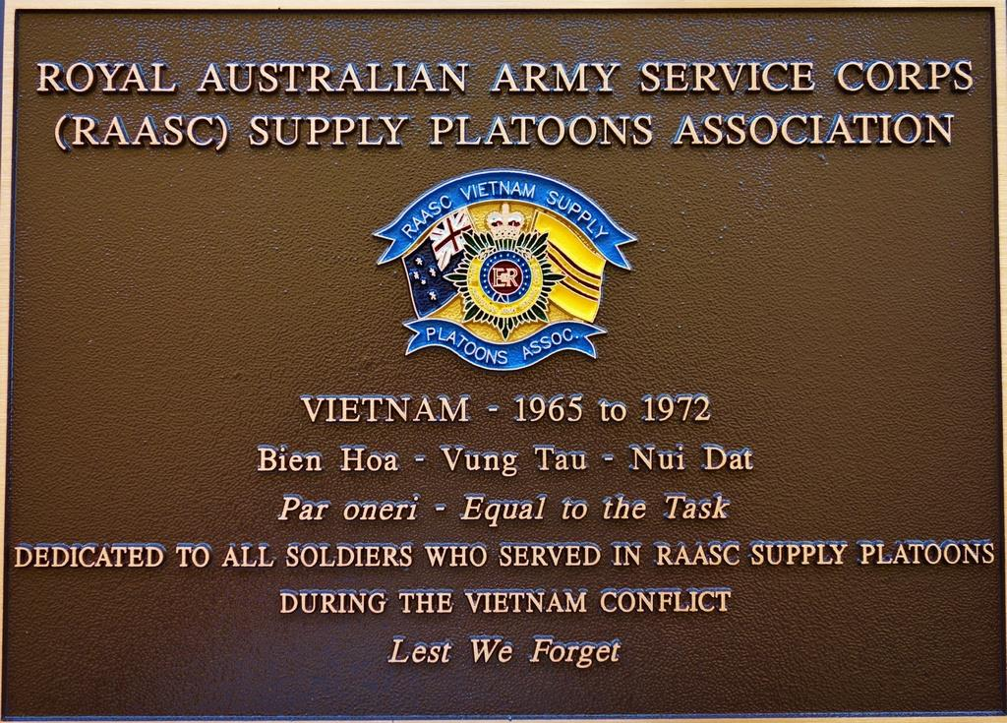

MASTER OF CEREMONIES Mr Graeme Sherriff

WELCOMING ADDRESS President: Mr Graeme Sherriff

PRAYER FOR THE NATION Chaplain: Padre Tom Fairhall

Almighty God, watch over all those serving in the Armed forces and those who still suffer disabilities through sickness or injuries suffered in war. Strengthen and encourage those who have been saddened by loss of loved ones, especially children deprived of a parent’s care and protection. Grant that the same courage and resolution, the same comradeship and service shown in the struggles in which our country is involved, may result in true and lasting peace. AMEN

PRAYER FOR THE FALLEN Led by Chaplain (said by all)

Almighty Father, we gather today to remember the souls of those who have given their lives in the service of our country, especially the former members of the Royal Australian Army Service Corps. We take time to remember those of our ranks who have since passed.

Into your hands, O Lord, we commend their spirits. Keep them in your peace and grant them eternal rest. May we and all who pass this way, recall with gratitude, the sacrifices of those who have helped keep our nation free. We make these prayers through Christ our Lord. AMEN

COMMEMORATIVE ADDRESS Committee Member:

WREATH LAYING

THE ODE President

They shall grow not old, as we that are left grow old
Age shall not weary them, nor the years condemn.
At the going down of the sun and in the morning
We will remember them.

Lest we forget

LAST POST (Flag lowered)

ONE MINUTES SILENCE

REVEILLE (Flag raised)

LEST WE FORGET

Response: Lest we forget

3.

NATIONAL ANTHEM ‘Advance Australia Fair’

Australians all let us rejoice, for we are young and free
We’ve golden soil and wealth for toil, our home is girt by sea
Our land abounds in nature’s gifts, of beauty rich and rare
In history’s page, let every stage, Advance Australia Fair
In joyful strains then let us sing, Advance Australia Fair.

RAASC PRAYER Led by Chaplain (said by all)

Almighty God, You call Your people to serve You in many different ways. Help us, the members of the Royal Australian Army Service Corps to be more than equal to the particular tasks allotted to us. Keep us true to the values of life we are committed to defend, through Jesus Christ our Lord. AMEN.

CLOSING PRAYER Chaplain

CLOSING Master of Ceremonies

Thank you for attending our RAASC Vietnam Supply Platoons Association (VSPA) Commemorative Service

